If you need help filling in this form, you can ask someone you know to help you or ask us and we can help you. Please answer the questions in the form below.

Name
Address
Email address
Telephone number
In this role we are looking for someone who has a learning disability and or Autism. Are you an Autistic person or a person with a learning disability?
Please tell us about times you have worked as part of a team

Please tell us about your ability to keep information confidential

Please tell us about your experience of and ability to notice things and ask questions

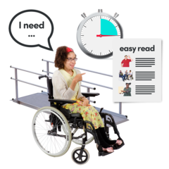
Please tell us if you are happy to share your own experiences of accessing services how your experience might help others

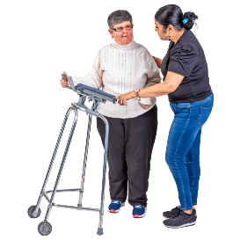
Please tell us about a time you have helped someone. What did you think and what did you do?

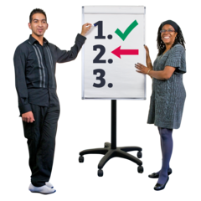
Tell us your experience of putting information together and presenting key findings to other people
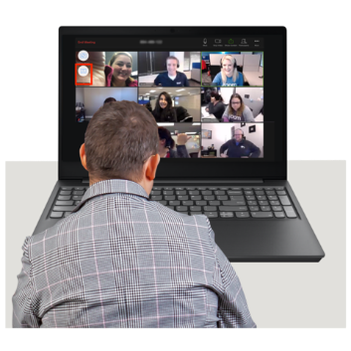
Please tell us your experience of using email, phone and apps like computers, smart phones and Apps like Zoom, WhatsApp or Microsoft Teams, with or without support.
We will interview you using Zoom – please tell us if you will need any help or equipment to do this
If someone filled in this form for you, please ask them to sign their name below
Please provide the name and contact details of two people who can give us a reference. If you are offered a job, we will ask these people if they think you will be good at it before you can start.

They can be people you have worked with before or who know you personally.

They should not be a family member.

Reference 1
Name:
Address:
Email:
Phone:
How do you know this person?
Reference 2
Name:
Address:
Email:
Phone:
How do you know this person?

Please return to:

jobs@yvc.org.uk

