Name

Date of referral
Address and Postcode
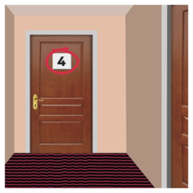
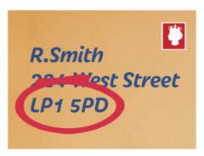
Can we write to you at this address? |  | YES |  | NO
Please tick your home type |  | Family home |  | Shared Lives/Adult Placement
Own home |  | Residential care |  | Independent supported living
Hostel |  | Hospital |  | I am currently homeless
Phone number
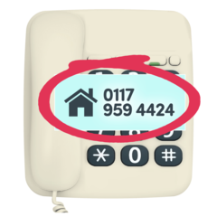
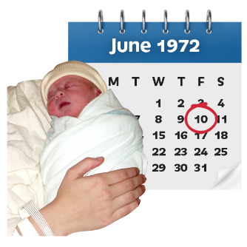
Date of birth

Do you have a learning disability?  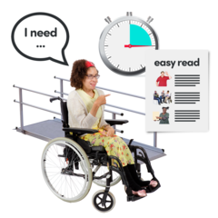 |  | YES |  | NO

What do you need support with? Please tell us as much as possible
Do you have a social worker? | Name
 | Their phone number
Who else supports you? | Name
 | Their phone number
How do they know you?
Who else supports you? | Name
 | Their phone number
How do they know you?
How will you tell us things? Do you use words, makaton, sign language, pictures, or gestures?
Is there anything we need to know about your health, for example epilepsy or diabetes?

Is there anything we should know to keep you and others safe? Tell us if there are times when you might get angry or upset.

Do you have a religion or a religious belief?
What is your ethnicity?
Please tick one
White British |  | Black or Black British ‐ African
White Irish |  | Black or Black British ‐ Caribbean
White ‐ Gypsy or Irish Traveller |  | Black or Black British ‐ Other
White – any other White background |  | Asian or Asian British ‐ Bangladeshi
Mixed: White \ Black Caribbean |  | Asian or Asian British ‐ Indian
Mixed: White \ Asian |  | Asian or Asian British ‐ Pakistani
Mixed: (Other Background) |  | Asian or Asian British ‐ Other
Mixed: White \ Black African |  | Asian or Asian British -Chinese
Mixed: White \ Black African |  | Other Ethnic Groups
Mixed ‐ White and Black Caribbean |  | Not Specified / Unknown
Mixed ‐ Other

About the information you have provided on this form
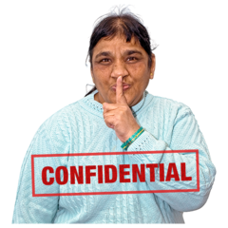 | Confidentiality  The personal things I talk about with Your Voice Counts will be kept private.  Your Voice Counts will only share the things I talk about if they think:  - I am in danger  - I am at risk of being harmed  - Someone else is at risked of being harmed  I am happy for Your Voice Counts to do this.  YES NO
Sharing and accessing information

I understand that Your Voice Counts might need to share information with organisations in order to help me. This might be the DWP, Job Centre or social work team.

I am happy for Your Voice Counts to do this.
YES NO
Attending Meetings

I understand that Your Voice Counts might support me to go to meetings

Your Voice Counts might need to go to meetings without me to speak up for me if I can’t be there or I don’t want to go. Your Voice Counts will always try to talk to me about this first to make sure I agree.

I am happy for Your Voice Counts to do this.

YES NO

General Data Protection Regulations Statement

There is a law called General Data Protection Regulation or GDPR. This law has rules that make sure that any information about you is kept safe. Your Voice Counts will make sure we follow these rules.

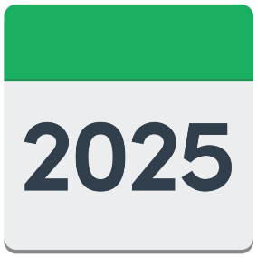 | The personal information on this form will be held safely and will only be used for helping you with the things you have asked us to.  We will keep the information for 6 years.
You have the right to ask for a copy of the information we hold about you.

You can ask for information about you to be changed or removed from the records we keep if you think we don’t need your information anymore.

You have the right to change your mind and tell us that you don’t agree to the things in this form anymore. This is called ‘withdrawing consent’. You can do this by getting in touch with Your Voice Counts.

You can also contact Your Voice Counts if you have any questions about this form or what we do with your personal information

Contact details

Jenny Rohde (Executive Assistant) jenny.rohde@yvc.org.uk 0191 478 6472

Peter Vine (Data Protection Officer) Peter.Vine@clearcomm.org

Complaints

You have the right to make a complaint against Your Voice Counts if you are not happy with how your personal information has been used.

If you want to make a complaint you can contact the Information Commissioner’s Office. This is their website:

https://ico.org.uk/concerns

You can also ring this number:

0303 123 1113
I understand
YES NO
Name
Date
Signed
Name of Staff Member

If you have filled this form in on behalf of someone else, please fill in your details below.
Name
How do you know this person?
Is the person aware of the referral?
Team or department if relevant
Organisation if relevant
Your contact details

Information for referrers
​Our advocacy services are open to adults who have learning disabilities and who live in South Tyneside or Gateshead. We may also be able to work with people who have learning disabilities who live elsewhere in the region if their social care support is provided by South Tyneside council.
​We aim to help people with any issue, providing they have a learning disability and are in our eligible areas. Most of our advocacy services work is issue-based and for the duration of the issue. We also run drop-in sessions in Gateshead and South Tyneside where people can receive initial help very quickly. For more information please call 0191 478 6472.

